Carti Hotel Management System

Use-Case-Realization Specification: Check-out

Version <1.0>

Revision History

| **Date** | **Version** | **Description** | **Author** |
| --- | --- | --- | --- |
| 25/Nov/2024 | 1.0 | Final Version | Hoang Sinh Hung |
|  |  |  |  |
|  |  |  |  |
|  |  |  |  |

Table of Contents

1. Introduction 4

1.1 Purpose 4

1.2 Scope 4

1.3 Definitions, Acronyms, and Abbreviations 4

1.4 References 4

1.5 Overview 4

2. Flow of Events—Design 4

3. Derived Requirements 6

Use-Case-Realization Specification: Check-out

# Introduction

## Purpose

This document describes how the Check-out use-case is realized within the design model of the Carti Hotel Management System projects.

## Scope

This document applies to the Carti Hotel Management System.

## Definitions, Acronyms, and Abbreviations

None.

## References

None.

## Overview

The use case's design and corresponding requirements are detailed in the following sections. Specifically, the flow of events in the design section includes the realization of the use case through a class diagram and a sequence diagram, accompanied by a concise textual explanation. The subsequent section outlines the derived requirements that must be considered during the implementation of the use case.

# Flow of Events—Design

The two diagrams below illustrate the necessary classes and the sequence of interactions required to implement the Check-out use case.

On the Receptionist Page, the receptionist enters the customer's name in the search bar and clicks the Search button. The Search Controller retrieves all matching customers and displays a list of results on the screen.

The receptionist selects a customer from the list, and the system navigates to the Customer Detail Page. The Booking Controller then fetches the customer's reservation history and displays it on the screen. The receptionist selects a specific reservation and clicks the Check-Out button to view the bill. The Booking Controller retrieves the bill for the selected reservation and displays it on the Reservation Detail Page.

For the monthly report, the Revenue Controller fetches data for each month, which is then presented on the page.

To finalize the check-out process, the receptionist clicks the Check-Out button, which prompts the system to update the database through the Customer, Reservation, and Room models. Finally, the receptionist clicks the Print Bill button, triggering the printer to generate a physical copy of the bill for the customer.

## Sequence diagram

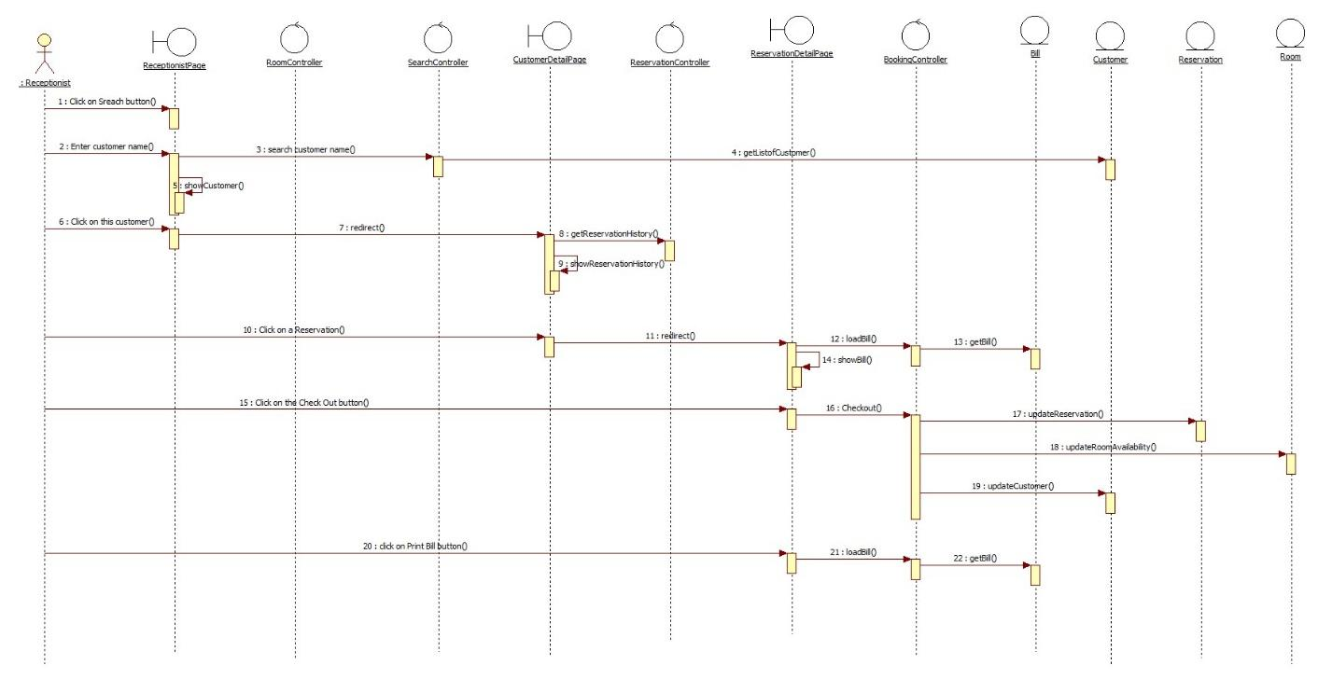

## Class diagram

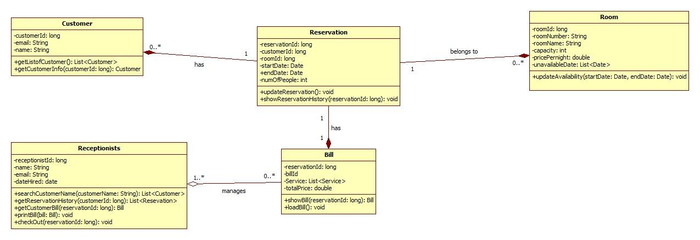

# Derived Requirements

None.